LOW BUDGET PRESS TRIP

Sustainable dry cow management

Mastitis is one of the most important illnesses in dairy industry. At the same time, there is not just one reason or way to treat it. As a multifactorial problem, dairy farmers, veterinarians, advisors as well as pharmaceutical industry are required to work together to improve the animal health and the wellbeing of modern dairy cows.

Even though antibiotic dry cow treatment is a useful and effective way to reduce new infections, concerns about resistances increase. Additionally, lots of the used antibiotic drugs belong to the group of reserve antibiotics that should be used in human beings exclusively.
Research show that selective dry cow treatment (just cows with high somatic cell count receive an antibiotic dry up treatment) as well as treatment protocols depending on the specific pathogen are opportunities to reduce the use of antibiotics. But there is a risk of more new infections in the following lactation. New treatment protocols require more knowledge about the history of every single cow (good documentation) and very precise and fast diagnostic tools. The challenges for farmers and veterinarians increase.

This Low Budget Press Trip wants to face the challenges and opportunities of selective dry cow treatment. Further, it wants to address the role of feeding, housing and herd management. In Detail, we will talk about the following topics:
- For which farms selective dry cow treatment could be an option? How does a modern mastitis treatment strategy look like? What else in feeding, housing etc. has to come along with drug treatment? Learn from two farmers how they improve their udder health in a holistic approach.
- What strategies does the pharmaceutical industry pursuit? What can they do on the way to a responsible handling of antibiotic drugs?
- What is the best way to measure udder health? Which indicators are useful? How can On-Farm-Mastitis-Tests support diagnostic and treatment of mastitis?

If you are interested, come and visit the border region of Germany and the Netherlands from an exciting dairy point of view!

Find more details about the trip below.

Day 1 - 5th of April

- Optional: tour through laboratory of Landeskontrollverband North Rhine-
Westphalia e.V.

Diagnostic has to be much more sensitive to reduce the use of antibiotics. A modern way is not just to measure somatic cell count, but differentiate the different types of somatic cells to see, if an infection is already chronic and how the chances of recovery are for one specific cow. So optionally the participants have the chance to visit the laboratory of Landeskontrollverband Northrhine-Westfalia, where such a modern analytic tool is running.

The Landeskontrollverband Northrine-Westfalia is federation that is responsible for Milk testing in quantity and quality, animal recording, controlling of quality management in milk.

Landeskontrollverband Nordrhein-Westfalen e.V.
Bischofstraße 85
47809 Krefeld

- Arrival, dinner, come together

Versuchs- und Bildungszentrum Landwirtschaft Haus Riswick
Elsenpaß 5
47533 Kleve

Day 2 - 6th of April
- During milking time, we will discuss the importance of milking routines and hygiene, visiting milking in the research barn of Haus Riswick. After breakfast we will tour through the research farm and learn about their actual projects and their results despite of animal feeding and housing.
The Research and education center Haus Riswick in Kleve, Germany, is one of two Research and Education centers for Agriculture of the Landwirtschaftskammer in Northrhine-Westfalia. Tasks are education in animal husbandry for agriculture students, farmers, teachers and advisers as well as research in dairy farming and feed production. The Landwirtschaftskammer promotes and supports agriculture and those who work for it, and strengthens rural areas in mission of the federal state of Northrine-Westfalia.

Haus Riswick has access to a modern research barn. They are able to keep 250 dairy cows in six feeding groups of 24 animals. Both feed and water intake are measured individually for each animal using weighing troughs. Additionally, they are able to investigate emission output of different parts of the barn (opportunity to compare different rations or shapes of floors).

- Transfer to MSD in Boxmeer (NL) and lunch. At MSD, we will have a brief introduction to MSD and listen to a presentation about dairy health management from a pharmaceutical point of view. After that, we will tour the facilities (amongst other with view into injector filling).
Host: Marco Labordus, Managing Director,
Pleun Penterman, Veterinarian Ruminants Business Unit, MSD Animal Health)

MSD Animal Health is one of the leading international companies in animal health. With the headquarter in the United States, the location in Boxmeer (NL) is important for research and production of medicinal products. For dairy cattle they provide different types of drugs, also antibiotics as well as vaccines. During the tour, we will see the sterile filling of udder injectors and packing of animal drugs.

MSD Animal Health
Wim de Körverstraat 35
5831 AN Boxmeer

- Transfer to Dutch dairy farm.

Dutch dairy farmers are some of the most advanced in Europe. Land is expensive, production is very intensive. So dairy farmers adapt new technologies to improve production and economics of their farms. At the same time, they have strict regulation despite the use of antibiotics.

- Transfer to Haus Riswick, Dinner

During the trip, we face new methods to measure mastitis and introduce on-farm mastitis diagnostic tools.

Day 3 - 7th of April

- Breakfast, transfer to German dairy farm

Regulation intensifies in Germany, too. So dairy farms have to change routines to reduce their use of antibiotic treatment. The right way to do that, is still part of a debate.

- Final discussion, end of LBPT at 12.00 o’clock

To help you with your planning, you find some travel information below.

Travelling

Versuchs- und Bildungszentrum Landwirtschaft Haus Riswick
Elsenpaß 5
47533 Kleve

By car
A B220 from Emmerich direction: exit “Emmerich”, Autobahn 3 Oberhausen – Arnheim
B B57 from Kalkar and Xanten direction
C B9 from Goch direction: exit „Kleve“, Autobahn 57 Moers – Nimwegen
D B9 from Kranenburg / Nimwegen direction
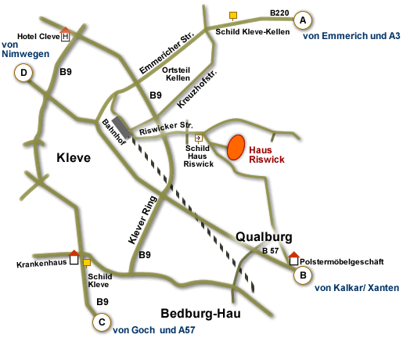
By train
RE10 “Niers-Express”: Düsseldorf - Krefeld - Kleve every 30 minutes. Railway station „Kleve“ to Haus Riswick – ca. 2 km (Taxi)

By plane
Airport “Weeze” (http://www.airport-weeze.de/en): from airport by bus / train / taxi, ca. 30 km to Haus Riswick

Costs

The fee of 130 € includes two overnight stays and the fee for ENAJ.
Sponsors help us with transfer/field trips, lunch and dinners. NOT included are travel expenses to event location.

Notes

Please apply to your national ENAJ organization.
If you have any questions to the registration process, please contact Dr. Elisabeth Legge (Elisabeth.Legge@lz-rheinland.de, +49 228-52006-547)!

Please make sure you don’t wear clothes, esp. shoes, that have been on other farms up to 14 days before!

